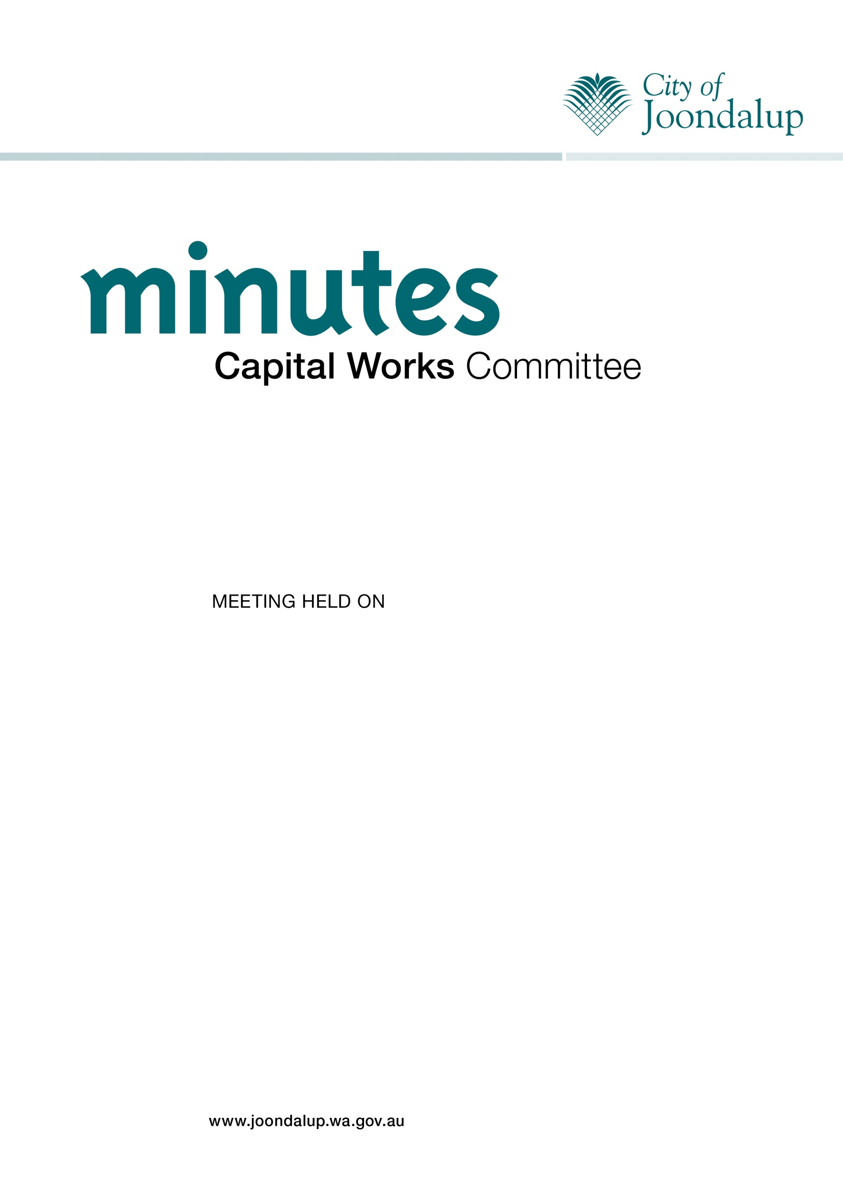
TUESDAY, 3 JULY 2012

TABLE OF CONTENTS

Item No | Title | Page No
 | Declaration of Opening | 3
 | Apologies/Leave of absence | 3
 | Confirmation of Minutes | 4
 | Announcements by the Presiding Person without discussion | 4
 | Declarations of Interest | 4
 | Identification of matters for which the meeting may sit behind closed doors | 4
 | Petitions and Deputations | 4
 | Reports | 5
Item 1 | Update on Capital Works Program for 2011/12 Financial Year – [102496] | 5
 | Motions of which previous notice has been given | 8
 | Requests for Reports for future consideration | 8
 | Closure | 8

Note:

Clause 77 of the City’s Standing Orders Local Law 2005 states:

“Unless otherwise provided in this local law, the provisions of this local law shall apply to meetings of committees with the exception of:

(a) clause 29 (Members seating;) and

(b) clause 54 (Limitation on members speaking.)”

CITY OF JOONDALUP

MINUTES OF THE CAPITAL WORKS COMMITTEE MEETING HELD IN CONFERENCE ROOM 2, JOONDALUP CIVIC CENTRE, BOAS AVENUE, JOONDALUP ON TUESDAY,
3 JULY 2012.

ATTENDANCE

Committee Members:

Cr Tom McLean, JP Presiding Member
Mayor Troy Pickard
Cr Brian Corr
Cr Christine Hamilton-Prime
Cr Philippa Taylor arrived at 5.56pm

Officers:

Mr Mike Tidy Director Corporate Services
Mr Charlie Reynolds Acting Director Infrastructure Services
Mr Brad Sillence Manager Governance and Marketing
Mr John Byrne Governance Coordinator
Mrs Deborah Gouges Governance Officer

DECLARATION OF OPENING

The Presiding Member declared the meeting open at 5.48pm.

APOLOGIES/LEAVE OF ABSENCE

Apologies

Cr Geoff Amphlett, JP.

Leave of Absence previously approved

Cr Liam Gobbert 12 July to 29 July 2012 inclusive.
Cr Russ Fishwick, JP 23 July to 28 July 2012 inclusive.
Cr Kerry Hollywood 23 July to 29 July 2012 inclusive.

CONFIRMATION OF MINUTES

MINUTES OF THE CAPITAL WORKS COMMITTEE HELD ON 12 JUNE 2012

MOVED Cr Hamilton-Prime, SECONDED Cr Corr that the minutes of the meeting of the Capital Works Committee held on 12 June 2012 be confirmed as a true and correct record.

The Motion was Put and CARRIED (4/0)

In favour of the Motion: Cr McLean, Mayor Pickard, Crs Corr and Hamilton-Prime.

ANNOUNCEMENTS BY THE PRESIDING PERSON WITHOUT DISCUSSION

Nil.

DECLARATIONS OF INTEREST

Nil.

IDENTIFICATION OF MATTERS FOR WHICH THE MEETING MAY SIT BEHIND CLOSED DOORS

Nil.

PETITIONS AND DEPUTATIONS

Nil.

REPORTS

Cr Taylor arrived at the meeting at 5.56pm during discussion of Item 1.

ITEM 1 UPDATE ON CAPITAL WORKS PROGRAM FOR 2011/12 FINANCIAL YEAR

WARD: All

RESPONSIBLE Mr Charlie Reynolds
DIRECTOR: Infrastructure Services

FILE NUMBER: 102496, 101515

ATTACHMENTS: Attachment 1 Capital Works Project Report 2011/12

PURPOSE

The purpose of this report is to provide the Capital Works Committee with an update on capital work activities for the 2011/12 financial year.

EXECUTIVE SUMMARY

The Capital Works Project Report for the 2011/12 financial year, as at 26 June 2012, is attached.

It is recommended that the Capital Works Committee NOTES the report on the
Capital Works Projects for 2011/12 forming Attachment 1 to this Report.

BACKGROUND

At its meeting on 15 May 2012 (CJ094-05/12 refers), Council resolved inter alia to establish a Capital Works Committee to:

- Oversee the monthly progress of the City’s annual Capital Works Program and review of the City’s Five Year Capital Works Program;
- Oversee the long term planning of major capital works projects not being the role of a Council Committee established for such purposes; and
- Consider recommendations to modify the City’s Capital Works.

DETAILS

The Capital Works Project Report for the 2011/12 financial year, as at 26 June 2012, is attached at Attachment 1.

Issues and options considered:

Not Applicable.

Legislation/Strategic Plan/Policy Implications

Legislation Subdivision 2 of Division 2 of Part 5 of the Local Government Act 1995.
City of Joondalup Standing Orders Local Law 2005.

A Committee cannot make decisions, on behalf of the Council, that require an absolute majority decision (Section 5.17 of the Local Government Act 1995), in which case, and in accordance with Section 6.8 of the Local Government Act 1995, includes approving expenditure not included in the City’s Annual Budget. The Capital Works Committee could only recommend to the Council to approve or modify capital works projects.

Strategic Plan

Key Focus Area: Leadership and Governance.

Objective: 1.3 To lead and manage the City effectively.

Policy: Not Applicable.

Risk Management Considerations:

Not Applicable.

Financial/Budget Implications:

Not Applicable.

Regional Significance:

Not Applicable.

Sustainability Implications:

Not Applicable.

Consultation:

Not Applicable.

COMMENT

The Capital Works Project Report for the 2011/12 financial year provides an update on the capital work activities undertaken for the year including details of carried forward and completed projects.

VOTING REQUIREMENTS

Simple Majority.

RECOMMENDATION

MOVED Mayor Pickard, SECONDED Cr Hamilton-Prime that the Capital Works Committee NOTES the report on the Capital Works Projects for 2011/12 forming Attachment 1 to this Report.

The Motion was Put and CARRIED (5/0)

In favour of the Motion: Cr McLean, Mayor Pickard, Crs Corr, Hamilton-Prime and Taylor.

Appendix 1 refers

To access this Attachment on electronic document, click here: Attach1agnCWC030712.pdf

MOTIONS OF WHICH PREVIOUS NOTICE HAS BEEN GIVEN

Nil.

REQUESTS FOR REPORTS FOR FUTURE CONSIDERATION

Mayor Pickard announced that Cr Ritchie has expressed an interest in joining the
Capital Works Committee with Cr Fishwick to be her deputy.

It was agreed that a report be prepared and presented to the 24 July 2012 Council meeting endorsing Cr Ritchie’s appointment to the Capital Works Committee with Cr Fishwick as her deputy.

CLOSURE

There being no further business, the Presiding Member declared the Meeting closed at
6.35pm, the following Committee Members being present at that time:

Cr Tom McLean, JP
Mayor Troy Pickard
Cr Brian Corr
Cr Christine Hamilton-Prime
Cr Philippa Taylor

